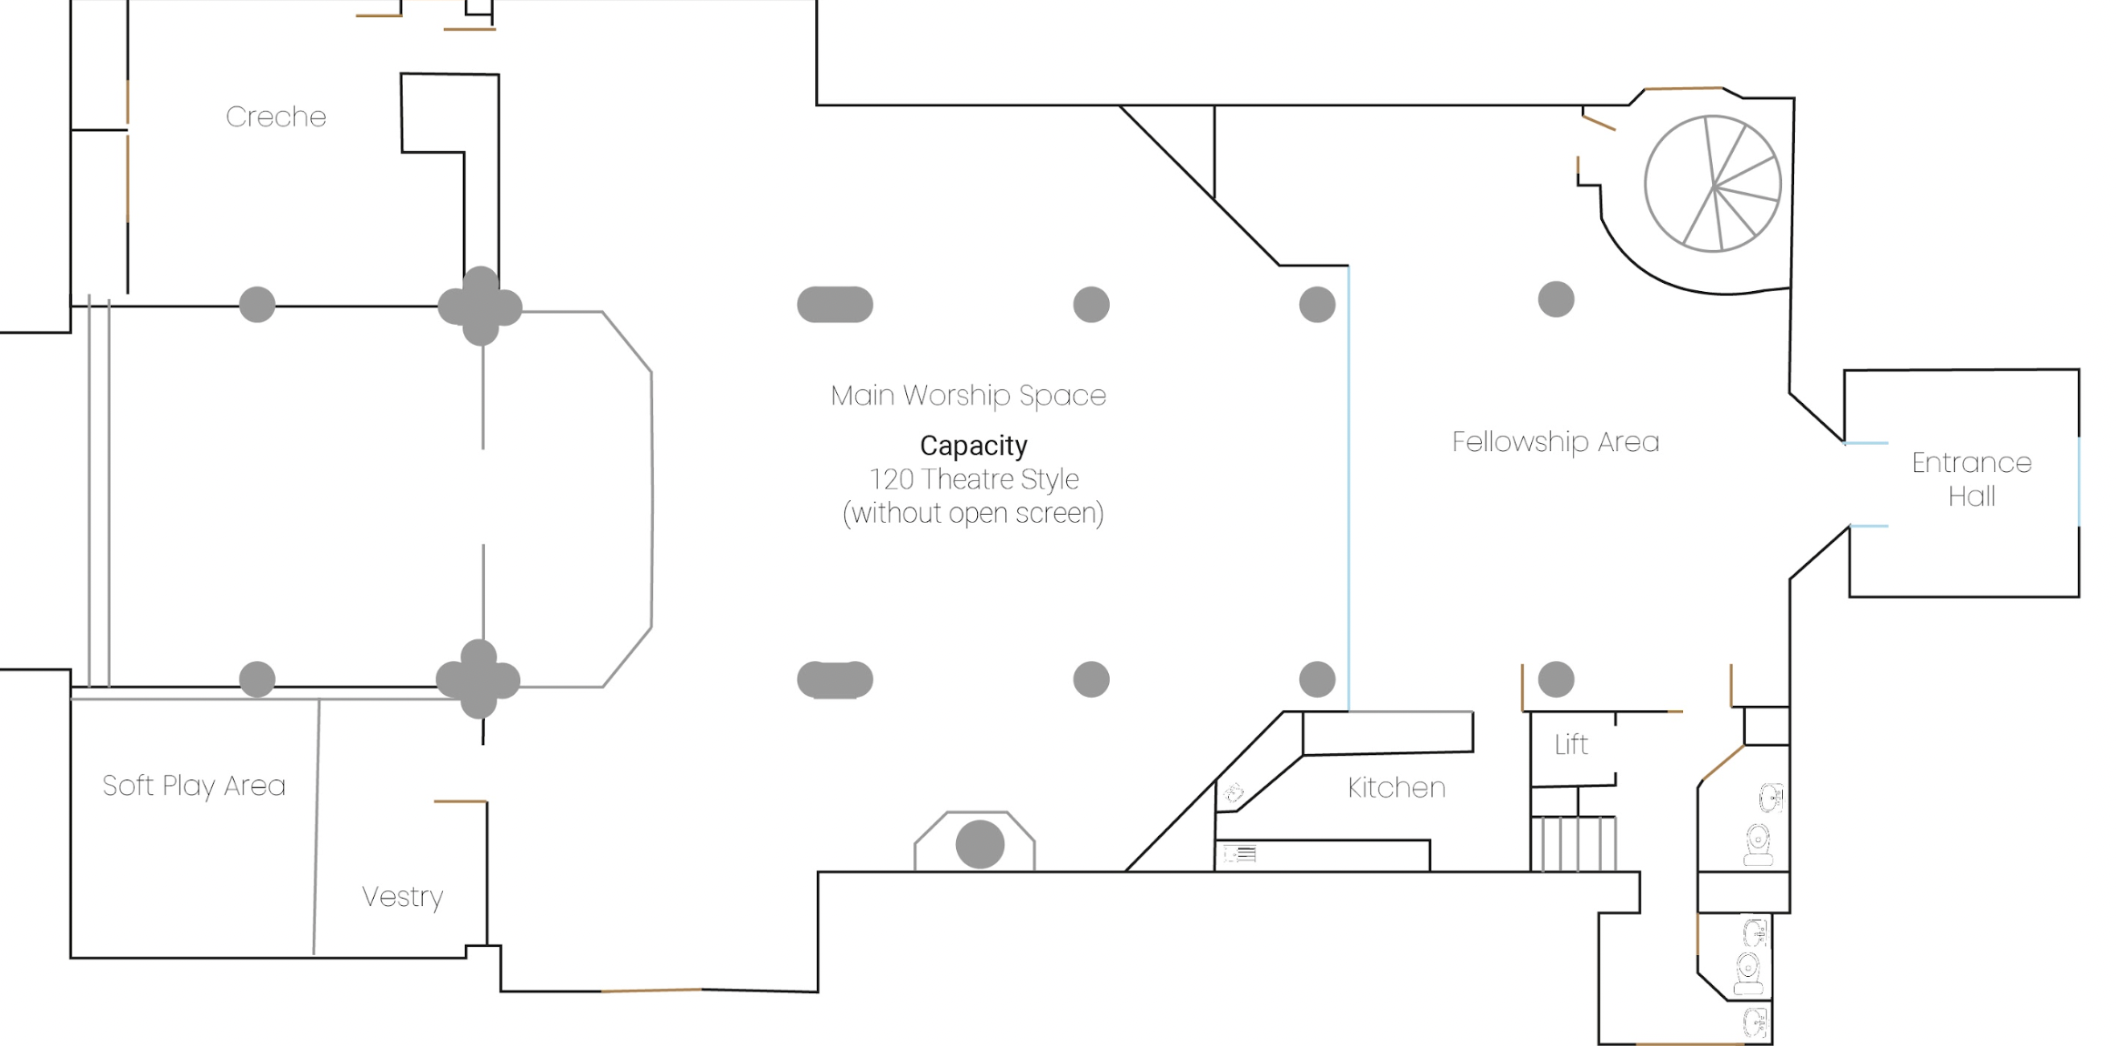

There is limited dedicated onsite parking but additional paid parking is available on local, residential streets. The church is also very well served by public transport.

Cost of hire
All spaces - £150 per hour
Filming - £200 per hour
Concessionary rates are available for charity/ church family/ regular hirings. Please enquire for more info.

AV equipment is available by agreement for which there may be an additional charge. We also have professional sound engineers and AV operators available to hire at an extra cost.

For examples of the types of events that could be held at this venue, see below for previous events and our offerings:
